Computer Project File

**Roll No: 9204142**

**By – Kanav Sethi - S7D**

**Report Card System**

**Project to maintain a file student.dat where add, delete, search, modify and display of report cards is possible**

#include<conio.h>

#include<stdio.h>

#include<process.h>

#include<fstream.h>

#include<iomanip.h>

class student //class definition

{

int rollno;

char name[50],grade;

int p_marks,c_marks,m_marks,e_marks,cs_marks,std;

float per;

void calculate() //function to calculate grade according to marks

{

per=(p_marks+c_marks+m_marks+e_marks+cs_marks)/5.0;

if(per>=60)

grade='A';

else if(per>=50 && per<60)

grade='B';

else if(per>=33 && per<50)

grade='C';

else

grade='F';

}

public:

void getdata() // function to get the details

{

cout<<"\nEnter The roll number of student ";

cin>>rollno;

cout<<"\n\nEnter The Name of student ";

gets(name);

cout<<"\nEnter The marks in physics out of 100 : ";

cin>>p_marks;

cout<<"\nEnter The marks in chemistry out of 100 : ";

cin>>c_marks;

cout<<"\nEnter The marks in maths out of 100 : ";

cin>>m_marks;

cout<<"\nEnter The marks in english out of 100 : ";

cin>>e_marks;

cout<<"\nEnter The marks in computer science out of 100 : ";

cin>>cs_marks;

calculate();

}

void showdata() //function to show the details

{

cout<<"\nRoll number of student : "<<rollno;

cout<<"\nName of student : "<<name;

cout<<"\nMarks in Physics : "<<p_marks;

cout<<"\nMarks in Chemistry : "<<c_marks;

cout<<"\nMarks in Maths : "<<m_marks;

cout<<"\nMarks in English : "<<e_marks;

cout<<"\nMarks in Computer Science :"<<cs_marks;

cout<<"\nPercentage of student is :"<<setprecision(2)<<per;

cout<<"\nGrade of student is :"<<grade;

}

void show_tabular() //function to show data in tabular form

{

cout<<rollno<<setw(12)<<name<<setw(10)<<p_marks<<setw(3)<<c_marks<<setw(3)<<m_marks<<setw(3)<<

e_marks<<setw(3)<<cs_marks<<setw(6)<<setprecision(3)<<per<<" "<<grade<<endl;

}

int retrollno() //function to return roll no

{ return rollno; }

};

fstream fp; //object declaration

student st; //object declaration

void write_student() //function to write data in student.dat

{

fp.open("student.dat",ios::out|ios::app);

st.getdata();

fp.write((char*)&st,sizeof(student));

fp.close();

cout<<"\n\nstudent record Has Been Created ";

getch();

}

void display_all() //function to read and display data from student.dat

{

clrscr();

cout<<"\n\n\n\t\tDISPLAY ALL RECORD !!!\n\n";

fp.open("student.dat",ios::in);

while(fp.read((char*)&st,sizeof(student)))

{

st.showdata();

cout<<"\n\n====================================\n";

getch();

}

fp.close();

getch();

}

void display_sp(int n) //function to display any particular record

{

int flag=0;

fp.open("student.dat",ios::in);

while(fp.read((char*)&st,sizeof(student)))

{

if(st.retrollno()==n)

{

clrscr();

st.showdata();

flag=1;

}

}

fp.close();

if(flag==0)

cout<<"\n\nrecord not exist";

getch();

}

void modify_student() //function to modify a record

{

int no,found=0;

clrscr();

cout<<"\n\n\tTo Modify ";

cout<<"\n\n\tPlease Enter The roll number of student";

cin>>no;

fp.open("student.dat",ios::in|ios::out);

while(fp.read((char*)&st,sizeof(student)) && found==0)

{

if(st.retrollno()==no)

{

st.showdata();

cout<<"\nPlease Enter The New Details of student"<<endl;

st.getdata();

int pos=-1*sizeof(st);

fp.seekp(pos,ios::cur);

fp.write((char*)&st,sizeof(student));

cout<<"\n\n\t Record Updated";

found=1;

}

}

fp.close();

if(found==0)

cout<<"\n\n Record Not Found ";

getch();

}

void delete_student() //function to delete a record

{

int no;

clrscr();

cout<<"\n\n\n\tDelete Record";

cout<<"\n\nPlease Enter The roll number of student You Want To Delete";

cin>>no;

fp.open("student.dat",ios::in|ios::out);

fstream fp2;

fp2.open("Temp.dat",ios::out);

fp.seekg(0,ios::beg);

while(fp.read((char*)&st,sizeof(student)))

{

if(st.retrollno()!=no)

{

fp2.write((char*)&st,sizeof(student));

}

}

fp2.close();

fp.close();

remove("student.dat");

rename("Temp.dat","student.dat");

cout<<"\n\n\tRecord Deleted ..";

getch();

}

void class_result() // function to display the result of a class

{

clrscr();

fp.open("student.dat",ios::in);

if(!fp)

{

cout<<"ERROR!!! FILE COULD NOT BE OPEN\n\n\n Go To Entry Menu to create File";

cout<<"\n\n\n Program is closing ....";

getch();

exit(0);

}

cout<<"\n\n\t\tALL STUDENTS RESULT \n\n";

cout<<"====================================================\n";

cout<<"Roll No. Name P C M E CS %age Grade\n";

cout<<"====================================================\n";

while(fp.read((char*)&st,sizeof(student)))

{

st.show_tabular();

}

fp.close();

getch();

}

void result() // result menu

{

int ans,rno;

char ch;

clrscr();

cout<<"\n\n\nRESULT MENU";

cout<<"\n\n\n1. Class Result\n\n2. Student Report Card\n\n3.Back to Main Menu";

cout<<"\n\n\nEnter Choice (1/2)? ";

cin>>ans;

switch(ans)

{

case 1 : class_result();break;

case 2 : {

do{

clrscr();

char ans;

cout<<"\n\nEnter Roll Number Of Student : ";

cin>>rno;

display_sp(rno);

cout<<"\n\nDo you want to See More Result (y/n)?";

cin>>ans;

}while(ans=='y'||ans=='Y');

break;

}

case 3: break;

default: cout<<"\a";

}

}

void entry_menu() // entry menu

{

clrscr();

char ch2;

cout<<"\n\n\n\tENTRY MENU";

cout<<"\n\n\t1.CREATE STUDENT RECORD";

cout<<"\n\n\t2.DISPLAY ALL STUDENTS RECORDS";

cout<<"\n\n\t3.SEARCH STUDENT RECORD ";

cout<<"\n\n\t4.MODIFY STUDENT RECORD";

cout<<"\n\n\t5.DELETE STUDENT RECORD";

cout<<"\n\n\t6.BACK TO MAIN MENU";

cout<<"\n\n\tPlease Enter Your Choice (1-6) ";

ch2=getche();

switch(ch2)

{

case '1': clrscr();

write_student();

break;

case '2': display_all();break;

case '3':

int num;

clrscr();

cout<<"\n\n\tPlease Enter The roll number ";

cin>>num;

display_sp(num);

break;

case '4': modify_student();break;

case '5': delete_student();break;

case '6': break;

default:cout<<"\a";entry_menu();

}

}

void main() // main function

{

char ch;

do

{

clrscr();

cout<<"\n\n\n\tMAIN MENU";

cout<<"\n\n\t01. RESULT MENU";

cout<<"\n\n\t02. ENTRY/EDIT MENU";

cout<<"\n\n\t03. EXIT";

cout<<"\n\n\tPlease Select Your Option (1-3) ";

ch=getche();

switch(ch)

{

case '1': clrscr();

result();

break;

case '2': entry_menu();

break;

case '3':exit(0);

default :cout<<"\a";

}

}while(ch!='3');

}

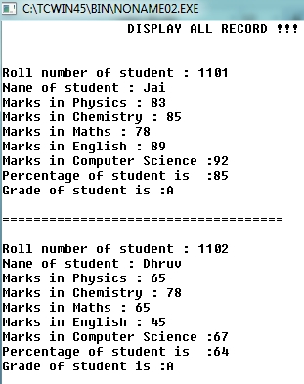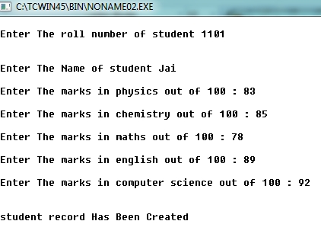

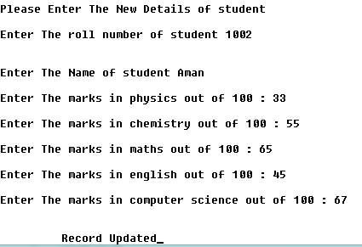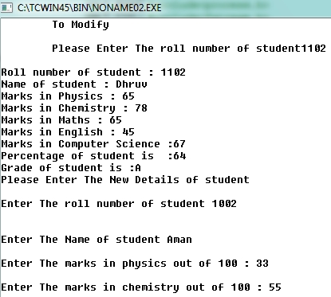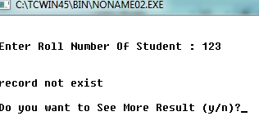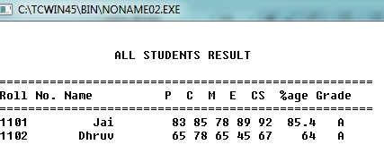

**BIBLIOGRAPHY**

* *GUIDANCE OF TEACHERS*
* W3 SCHOOL TUTORIALS
* www.yahoo.answers.com
* [www.google.co.in](http://www.google.co.in)
* [www.icbsc.project.com](http://www.icbsc.project.com)

**ABOUT THE PROJECT AND ITS USES**

THIS PROJECT IS USED TO KEEP A RECORD AND DISPLAY THE REPORT CARDS OF STUDENTS OF A PARTICULAR SCHOOL. YOU CAN SEARCH THE RESULT OF AN INDIVIDUAL STUDENT OR GROUP THEM ACCORDING TO CLASS RESULT.

THIS PROJECT USES DATA FILE HANDLING AND STORES ALL THE DATA IN A FILE NAMED STUDENT.DAT.

WHEN OPENED TWO FUNCTIONS ARE DISPLAYED – RESULT MENU AND ENTRY MENU. RESULT MENU CONTAINS CLASS RESULT AND RESLUT OF INDIVIDUAL STUDENT WHILE THE ENTRY MENU CONTAINS FUNCTIONS TO CREATE, DISPLAY, SEARCH, MODIFY AND DELETE SUDENT RECORDS.

**SOURCE OF IMPROVEMENT**

THIS PROJECT COULD BE FURTHER IMPROVED BY TURNING IT INTO A WEB PORTAL OR SMART PHONE APPLICATION WHERE PEOPLE CAN ACCESS THEIR REPORT CARDS FROM THEIR PHONES OR THROUGH THE INTERNET.

WE COULD ALSO ADD MORE FUNCTIONS AND USE THIS PROGRAM ON A COMMERCIAL SCALE BY PROVIDING ONLINE REPORT CARD STORING/PORTAL SERVICE TO DIFFIRENT SCHOOLS.

WE COULD ALSO ADD AFEW PICTURES AND COLOURS TO MAKE THE PROGRAM MORE APPEALING.

**INDEX**

|  |  |  |
| --- | --- | --- |
| **S.NO** | **DESCRIPTION** | **PAGE NO** |
|  | ACKNOWLEDGEMENT |  |
|  | CERTIFICATE |  |
| 1 | ABOUT THE PROJECT AND ITS USES |  |
| 2 | SOURCE OF IMPROVEMENT |  |
| 3 | SOURCE CODE | 1 - 6 |
| 4 | SAMPLE OUTPUTS | 7 |
| 5 | BIBLIOGRAPHY | 8 |